Developing a web application to improve communication at a software company.

**E. Dreyer**

Research methodology for the Dissertation submitted in partial fulfillment of the requirements for the degree *Bsc in Information Technology Hons* at the Vaal Campus of the North-West University

Supervisor: Dr. Suné Van Der Linde

Co-supervisor: Mr. Luke Coetzee

Date of submission: 2021/05/12

Version: 1.0

Table of Contents

LIST OF ABBREVIATIONS iii

Chapter 3: Literature review 1

1. Project description 1

2. Problem description and background 1

3. Aims and objectives of project 2

4. Literature review 2

4.1. Introduction 2

4.2. Importance of good communication 2

4.3. Methods of communicating 3

4.3.1. Conclusion 5

4.4. Interruptions 5

4.5. Human-computer interaction (HCI) 5

4.5.1. Simple and natural dialogue 6

4.5.2. Speak the users’ language 6

4.5.3. Minimize the users’ memory load 7

4.5.4 Consistency 8

4.5.5. Feedback 8

4.5.6. Clearly marked exists 9

4.5.7. Shortcuts 10

4.5.8. Good error messages 10

4.5.9. Prevent Errors 11

4.5.10. Help and documentation 12

6. Summary 12

7. Reference List 13

LIST OF ABBREVIATIONS

EU European Union (Abbreviation)

List of Figures

Figure 1: Simple and natural dialogue 6

Figure 2: Speak the user's language 7

Figure 3: Minimize the users' memory load 7

Figure 4: Consistency 8

Figure 5: Feedback 9

Figure 6: Clearly marked exists 9

Figure 7: Shortcuts 10

Figure 8: Good error messages 11

Figure 9: Prevent Errors 11

Figure 10: Help and documentation 12

List of Tables

**No table of figures entries found.**

Chapter 3: Literature review

# 1. Introduction

The goal of this study is to develop a web application that can be used to enhance communication between developers and management at a South African software development company. To reach the goal of this study, an evaluation to improve the communication using user interface design in a software development environment .

According to Cambridge University (2015), research is a detailed study of a subject, but more specifically to reach a new understanding or to discover new information. This is described as a number of overlapping or similar activities that involve the search of information. Research is done by collecting data and documentation on a specific topic then analysing and interpreting the data or information. Research is conducted with the goals being: to evaluate the validity of an interpretive framework or hypothesis, to gather knowledge and share the findings in an appropriate manner and generate questions to be inquired further.

# 

# 2. Problem description and background

In the corporate world, businesses rely on effective communication to succeed. Developers lack the number of screens that they need to keep all their important tabs open. This makes it harder for important messages to reach developers and influences productivity and creativity (Schrader, 2018).

As a solution, an artifact has to be developed to assist with the effectiveness of communication in the industry.

# 3. Aims and objectives of project

This study proposes the development of a communication web application that can easily be viewed in an office by all employees to allow easy access to important communication regarding specific software development projects. Where the primary objective is to develop a web application for a South African software development company that allows for easy access to important communication relating to specific project.

# 4. Literature review

## 4.1. Introduction

According to Rowley and Slack (2004) a literature review is conducting a summary of a subject in a field that promotes the identification of distinct research questions. A literature review needs to gather information through the use of different types of sources, such as books, professional journal articles and websites to find relevant information.

In this study the literature will be used to create a bigger view on the research as the background is explained and what paths was taken to reach the objective of this study. The literature review will ensure further insight in the research field (Knopf, 2006).

The goal of this chapter is to gain insight into the different ways in which communication can take place in the industry, as well as human-computer interaction to ensure that the web application is designed in the most user-friendly way.

In the next section of the study, the importance of good communication is discussed.

## 4.2. Importance of good communication

It is very important to have good communication methods when working in the software development industry. When passing information about code, requirements and bugs it is crucial that information gets passed on correctly to the developers and to the company (Hellgren, 2018). To ensure that the stakeholders get what they want, there needs to be a strong common understanding between the one that is making a request and the person that is completing the request. This common understanding can either lead to improving the project or someone spending time on a feature that is ultimately not what the users wanted, increasing the cost of the project (Dovleac, 2015).

For every scenario in a project, there is an optimal way of communicating. In the next section of the study, the different methods of communicating are discussed.

## 4.3. Methods of communicating

There are various platforms used for communication within a work setting. According to (Hellgren, 2018), companies use email, instant messaging, wikis, chat systems, issue queues, social media, drawing or multimedia. Each communication method will be discussed in detail in the next section of the paper.

**Email –** A study exploring the amount of time a person spends reading and responding to emails, reports that an average person uses 28% of their work time reading, replying and writing emails (Hackeling, 2021). It is alarming to consider employees spending more than a quarter of their work time on emails, and in some cases, it involves personal emails as well. To avoid reading unnecessary emails, most companies advise their employees not to use their personal emails for anything work related (Niinimaki, 2011).

**Instant messaging –** Examples of instant messaging include WhatsApp, Skype, and Slack. Most companies only use one form of an instant messaging system (Leano, 2020), where some companies use more than one, this makes it exponentially harder for important information to reach the desired person (Dittrich & Giuffrida, 2011). The main disadvantage of instant messaging systems is that people miss messages because they are not always on their phones or at their computers (Hellgren, 2018).

**Wikis –** Wikis are widely used by many organizations, they are a powerful way of communicating information to a group of people, but lack the functionality to notify that group of people, with important information (LeBar, 2017). Most wikis also do not have good version control for people to see who changes information and at what time (Hellgren, 2018). They also need to be kept up to date, or else they do not benefit the project (Minocha et al., 2008).

**Chat Systems** – Chat applications like Rocket.chat, IRC and LiveAgent. Chat systems are great for sharing a lot of information to a group of people (Phpzag, 2021). They also do not overload the users when sharing information, like an Instant messaging system, because users can read the messages on their own time and concentrate on what is being said (Hellgren, 2018). A drawback of this form of communication is that you do not always want people to read the information on their own time, you want them to work on the feature or bug when you ask them to do so. They also lack notifications when new content is uploaded.

**Issue queues –** Examples of issue queues include Bugzilla, Jira, or Trello to exchange information about development. The problem with this is the lack of feedback, when someone completed a feature or bug, as they are just moved around to the specific topic with no explanation on why it is there (Zepel, 2021). This communication method brings a lot of value to the development process, this is useful as a side feature for this study and will definitely help solve the main objective (Bérczes et al., 2012).

**Social media –** Many social media platforms, for example Workplace by Facebook, have tools that allow companies to have their own channels for employees (Hellgren, 2018). Each employee has their own voice, and seeing employees work on problems in their own way. The downside of using this method is that the company pays for the brand. This making it more expensive than for example using an issue queue, and with social media platforms selling their user data for advertising, the security is not the best if you are discussing private business related issues (Blaszkiewicz, 2017).

**Drawing –** Drawing rich pictures is a great way to get employees to see things in new perspectives (Elin, 2012). The problem with this is combining verbal communication because you are not always in the same room or using another communication method (Cockburn, 2006). Same goes for making a PowerPoint or digital images. There is also poor version control as you cannot go back to older versions of the drawing (Hellgren, 2018).

**Multimedia –** methods include the use of audio recording or videos and is perfect for sharing media files to multiple people. This is beneficial for making training videos, so that you only have to explain something once, the problem is keeping the videos up to date, and people also find it harder to ask questions when they are watching a video compared to someone explain to them in person (Sarowardy, 2019).

## 4.3.1. Conclusion

There are more communication methods, but these are the most popular amongst software developing companies (Hellgren, 2018). All of them have their own advantages and disadvantages and can cause developers to spend time on things that are necessary for the development of the project, or waste time on something that does not add to the completion of the project (Storey et al., 2016).

## 4.4. Interruptions

According to Thorne (2020) it takes a person an average time of 25 minutes (to be exact, 23 minutes and 15 seconds) to return to a task after being interrupted. This can be frustrating to developers, and lost time can cost the company money. To be constantly interrupted, can cause a decrease in job satisfaction and lead to performance issues.

For this study, a method that would be most applicable is one that does not immediately interrupt a developer, while still being notified that there is important information that needs to be attended to. This will allow the developer or project manager to continue with what they are busy with and allow them to make it part of their routine to check their notifications.

## 4.5. Human-computer interaction (HCI)

According to Hinze-Hoare (2007) HCI is the way in which an artifact is designed to provide the best user experience. For one to achieve the best user experience, you need to understand the interaction between the system and the user (Terblanche, 2014). Human-computer interaction helps with understanding what the difference between a good and a bad system is, but it does not guarantee the development of a successful product (Blackwell, 2010).

Hinze-Hoare (2007) has produced ten rules that should be followed by all interface designers to guide them to create the best user experience. In the next section of the paper, the ten rules will be listed and explained in detail, with example of how it should be done in the study.

## 4.5.1. Simple and natural dialogue

There should not be any sight of irrelevant information. This is because every extra information on the screen competes for visibility (Chen, 2018).

For example, when an administrator wants to edit another user, they do not want to see the Id that we are using in the database. This will be of no relevance to the user and should be left out.

Figure 1: Simple and natural dialogue

As shown in Figure 1, there are no unnecessary information that overloads the user.

## 4.5.2. Speak the users’ language

The information that is available to the user should be expressed so that the user understands, and is familiar to the concepts, rather than what is understood by the system or the operator.

In this study, this will be achieved by making sure that no “programming language” is used, for example not showing the calculations that was done, but only the final answer.



Figure 2: Speak the user's language

As shown in Figure 2, the user can clearly see that they had 57,6% more sales today. The user does not see “var percent = 100% – 42,4%”.

## 4.5.3. Minimize the users’ memory load

The importance here is to not have the user remember information from one page to the other. The user’s information should be easily retrievable.

For example, when an administrator clicks on one user profile, he does not want to remember the users name before he changes it. The information should already be on the page.

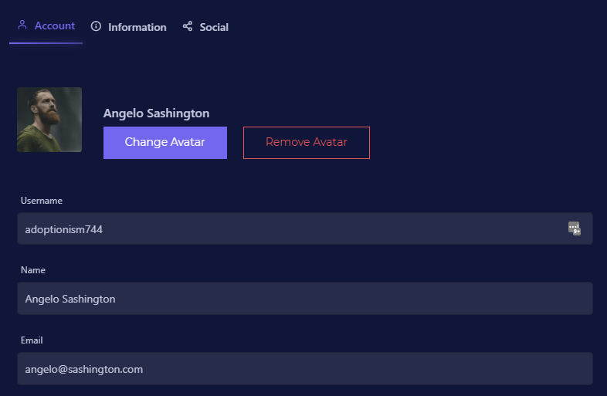

Figure 3: Minimize the users' memory load

As shown in Figure 3, the administrator clicked on the user “Angelo Sashington”, although his username was shown on the user list, it also shows under “Username”.

## 4.5.4 Consistency

This means that all generic buttons should be on the same place no matter where they occur in the system.

For this study, this is easily shown in the navigation bar at the top of every page. This navigation bar does not move and is always at the top for the user to have access to their profile and other tasks.

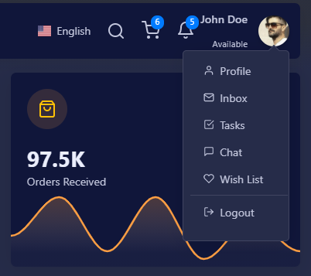

Figure 4: Consistency

This is also applicable to “save”, “delete”, and “cancel” buttons that should always be on the bottom of the page as well as having the same colour all over the system, for example delete should always be red and save should always be green.

## 4.5.5. Feedback

The user should always be aware of what is going on in the system, in a relevant and timely manner.

For example, when the user finished making changes and clicks on “save”, there should be a feedback notification stating that they did everything correctly and their changes have been successfully saved, or that their changes have been unsuccessful because the system is down.



Figure 5: Feedback

This is also applicable to loaders that show that the page is still loading, or that the changes are being applied to the database.

## 4.5.6. Clearly marked exists

Errors can be easily made by a user, thus they need an easy way to return to the previous state without having to proceed with their mistake.

For example, on every page, where you can edit or add data there is a “cancel” or “reset” button, that takes you back to the previous state.



Figure 6: Clearly marked exists

This also falls under consistency, as exists has to be on every page at the same place, so that the user always knows how to exit the page.

## 4.5.7. Shortcuts

This is used to speed up the interaction with the system by a user.

For the design of this study, there is a clear menu tab on the left of the page, this can be used to navigate around the system. This menu bar will always be on the screen to help navigate the user to the page that they desire.

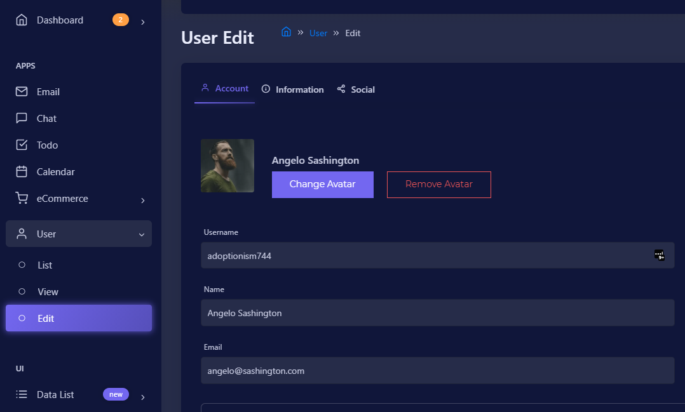

Figure 7: Shortcuts

As shown in Figure 7, there are also different menu levels, such as “List” users, “view” users, and “Edit” users. This makes it easier for experienced user to get to their desired outcome easier.

## 4.5.8. Good error messages

Error messages should be displayed in plain language for the user to understand what they need to do to resolve the problem.

For this study, there is a notification system to notify when the user did something wrong. This will show up on the bottom right corner of the page.





Figure 8: Good error messages

This also falls under consistency and feedback, as this should always show up at the same place, when the user did something wrong, and letting the user knowhow to fix their mistake.

## 4.5.9. Prevent Errors

This can be done by carefully designing what the user have access to. This can be done by setting the user permissions and having them see only the things that they are allowed to see.

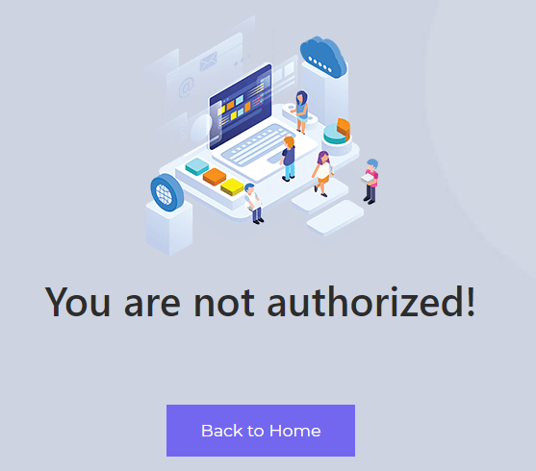

Figure 9: Prevent Errors

As shown in Figure 9, bugs do occur, and users get access to things that they should have access to. This can be prevented by setting up the backend to look at the users’ permissions and when the user does not have access to the page it redirects to the page shown in Figure 9. The “Back to Home” button takes them back to the previous state in the system.

## 4.5.10. Help and documentation

If your system speaks for itself, it can be used without documentation, but if the users need help with anything in the system, it can be easy to allocate.

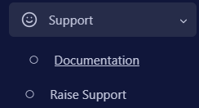

Figure 10: Help and documentation

As shown in Figure 10, in the menu tab, there will be a section where the user can access the documentation and ask for support. The documentation should be focused on the users’ tasks and the steps to achieving specific solutions.

# 6. Summary

The goal of this chapter was to gain insight into the different ways in which communication can take place in the industry, as well as human-computer interaction. This is achieved by looking at what communication method is most suitable for each scenario.

By looking at human-computer interaction principles, the artifact can be designed in the most user-friendly manner and be used as a “check-list” to ensure that every principle is followed.

# 7. Reference List

Bérczes, T., Sztrik, J., & Orosz, P. (2012). Tool supported modeling of sensor communication networks by using finite-source priority retrial queues. *Carpathian Journal of Electronic and computer engineering*, *5*, 13.

Blackwell, A. (2010). Human Computer Interaction. <https://www.cl.cam.ac.uk/teaching/1011/HCI/HCI2010.pdf>

Blaszkiewicz, S. (2017). Can Workplace by Facebook, work? <https://www.getapp.com/resources/can-facebook-at-work-work/>

Chen, X. (2018). Signal–to–Noise Ratio. <https://www.nngroup.com/articles/signal-noise-ratio/#:~:text=Definition%3A%20In%20human%E2%80%93computer%20interaction%2C%20the%20signal%E2%80%93to%E2%80%93noise%20ratio%20represents,anything%20%E2%80%94%20text%20content%2C%20visual%20elements%2C%20or%20animation>.

Cockburn, A. (2006). *Agile software development: the cooperative game*. Pearson Education.

Dittrich, Y., & Giuffrida, R. (2011). Exploring the role of instant messaging in a global software development project. 2011 IEEE Sixth International Conference on Global Software Engineering,

Dovleac, L. (2015). The role of new communication technologies in companies' sustainability. *Bulletin of the Transilvania University of Brasov. Economic Sciences. Series V*, *8*(1), 33.

Elin, S. (2012). Drawing and Painting as a Tool for

Communication. <https://www.duo.uio.no/bitstream/handle/10852/37146/NewMasterThesistemplate%5B2%5D-8.pdf?sequence=1>

Hackeling, E. (2021). How much time are you spending on email? . <https://frontapp.com/blog/how-much-time-are-you-spending-on-email>

Hellgren, H. (2018). Communicating in software development. <https://hackernoon.com/communicating-in-software-development-f3434c52eb23>

Hinze-Hoare, V. (2007). The review and analysis of human computer interaction (HCI) principles. *arXiv preprint arXiv:0707.3638*.

Knopf, J. W. (2006). Doing a literature review. *PS: Political Science and Politics*, *39*(1), 127-132.

Leano, M. (2020). WHY INSTANT MESSAGING IS THE TOP COMMUNITION TOOL FOR BUSINESSES. <https://newmediaservices.com.au/instant-messaging/#:~:text=Instant%20messaging%2C%20originally%20created%20for%20entertainment%20and%20social,messaging%20marketing%2C%20lead%20generation%2C%20and%20customer%20support%20purposes>.

LeBar, Z. (2017). What Are Wikis, and Why Should You Use Them? <https://business.tutsplus.com/tutorials/what-are-wikis-and-why-should-you-use-them--cms-19540>

Minocha, S., Petre, M., & Roberts, D. (2008). Using wikis to simulate distributed requirements development in a software engineering course. *International Journal of Engineering Education*, *24*(4), 689-704.

Niinimaki, T. (2011). Face-to-face, email and instant messaging in distributed agile software development project. 2011 IEEE Sixth International Conference on Global Software Engineering Workshop,

Phpzag, T. (2021). Build Live Chat System with Ajax, PHP & MySQL. <https://www.phpzag.com/build-live-chat-system-with-ajax-php-mysql/#:~:text=Chat%20System%20or%20Chat%20application%20is%20mainly%20used,to%20assist%20them%20regarding%20services%20and%20resolve%20issues>.

Rowley, J., & Slack, F. (2004). Conducting a literature review. *Management research news*.

Sarowardy, M. H. (2019). The Issues and Challenges of Using Multimedia at a District Level. <https://www.scirp.org/html/11-6304491_93691.htm>

Schrader, J. (2018, 30 July). *How Your Cell Phone Habits Impact Your Productivity*. <https://www.psychologytoday.com/us/blog/why-bad-looks-good/201807/how-your-cell-phone-habits-impact-your-productivity>

Storey, M.-A., Zagalsky, A., Figueira Filho, F., Singer, L., & German, D. M. (2016). How social and communication channels shape and challenge a participatory culture in software development. *IEEE Transactions on Software Engineering*, *43*(2), 185-204.

Terblanche, J. T. (2014). Using HCI principles to design interactive learning material. *Mediterranean Journal of Social Sciences*, *5*(21), 377.

Thorne, B. (2020). How Distractions At Work Take Up More Time Than You Think. <http://blog.idonethis.com/distractions-at-work/#:~:text=It%20takes%20an%20average%20of%20about%2025%20minutes,University%20of%20California%2C%20Irvine.%20Multiple%20studies%20confirm%20this>.

Zepel. (2021). *8 Problems You’ll Face By Using Trello for Agile Web Development*. <https://zepel.io/blog/problems-using-trello-for-agile-web-development/>